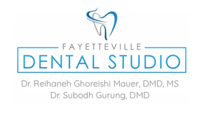

**CONSENT TO RELEASE OF DENTAL TREATMENT RECORDS**

**Patient Information:**

**Name: _________________________________________**

**DOB: __________________________**

**I, hereby certify that I am: (check one)**

**____ The Patient**

**____ The Parent of the patient, who is under age 18**

**I hereby request and authorize the office of Fayetteville Dental Studio, Dr. Subodh Gurung and/or Dr. Reihaneh Mauer to release and obtain my dental treatment records and x-rays as follows: (Check one)**

**______ to me (I will pick them up)**

**______ to me at the following address: ____________________________________________________**

**______ to the following named person, who will pick up the records for me: _____________________**

**______ to the following named Dental Office: _______________________________________________**

**______to the following email address: _____________________________________________________**

**_____________________________________________ Date: ______________**

**Signature of Patient or Patients Legal Guardian**